The Empty The Empty Chain

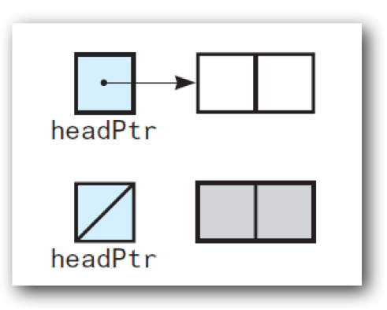

Nod

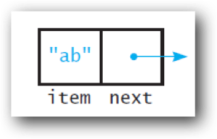The Class Node

#ifndef NODE_H_   
#define NODE_H_

template<class ItemType>

class Node

{

public:

Node(const ItemType& an_item);   
Node(const ItemType& an_item, Node<ItemType>*next_node_ptr);  void setItem(const ItemType& an_item);   
void setNext(Node<ItemType>* next_node_ptr);   
ItemType getItem() const;   
Node<ItemType>* getNext() const;

private:

ItemType item_; // A data item

Node<ItemType>* next_; // Pointer to next node

}; // end Node

#include "Node.cpp"

#endif // NODE_H_

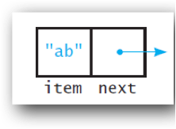Node Implementation

#include “Node.hpp”.

template<typename ItemType> Node<ItemType>::Node() : next_(nullptr)

{  
} // end default constructor

The constructor

template<class ItemType>

Node<ItemType>::Node(const ItemType& an_item) : item_(an_item), next_(nullptr)   
{  
} // end constructor

template<class ItemType>

Node<ItemType>::Node(const ItemType& an_item,

Node<ItemType>* next_node_ptr) :  item_(an_item), next_(next_node_ptr)

{

} // end constructor

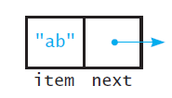Node Implementation

The “*setData*” members

#include “Node.hpp”

template<typename ItemType>   
void Node<ItemType>::setItem(const ItemType& an_item)

{

item_ = an_item;

} // end setItem

template<class ItemType>   
void Node<ItemType>::setNext(Node<ItemType>* next_node_ptr)

{

next_ = next_node_ptr;

} // end setNext

Node Implementation

The “*getData*” members

#include “Node.hpp”

template<typename ItemType>   
ItemType Node<ItemType>::getItem() const

{

return item_;

} // end getItem

template<class ItemType>   
Node<ItemType>* Node<ItemType>::getNext() const

{

return next_;

} // end getNext

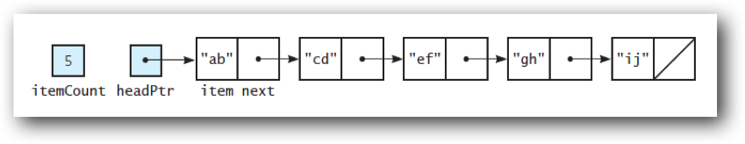A Linked Bag ADT

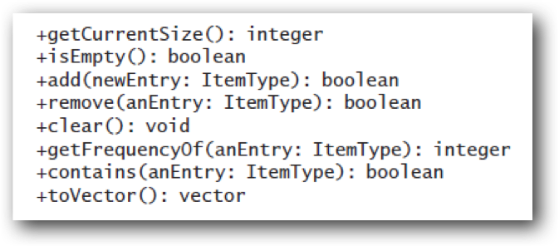

The Class LinkedBag

#ifndef LINKED_BAG_H_

#define LINKED_BAG_H_

#include "BagInterface.hpp"

#include “Node.hpp" template

<typename ItemType>

class LinkedBag

{  public:

LinkedBag();   
LinkedBag(const LinkedBag<ItemType>& a_bag); // Copy constructor

~LinkedBag(); // Destructor   
int getCurrentSize() const;   
bool isEmpty() const;   
bool add(const ItemType& new_entry);   
bool remove(const ItemType& an_entry);   
void clear();   
bool contains(const ItemType& an_entry) const;   
int getFrequencyOf(const ItemType& an_entry) const;  std::vector<ItemType> toVector() const;

private:

Node<ItemType>* head_ptr_; // Pointer to first node   
int item_count_; // Current count of bag items

// Returns either a pointer to the node containing a given entry  // or the null pointer if the entry is not in the bag.  Node<ItemType>* getPointerTo(const ItemType& target) const;

}; // end LinkedBag

//More than one public method will need to know if there is a pointer to a target so we separate it out into a private helper function (similar to ArrayBag but here we get pointers rather than indices)

LinkedBag Implementation

#include “LinkedBag.hpp”  the default constructor

template<typename ItemType>  privet data mem intializ

LinkedBag<ItemType>::LinkedBag() : head_ptr_(nullptr), item_count_(0)   
{

} // end default constructor

add(const ItemType& new_entry)

Where should we add?

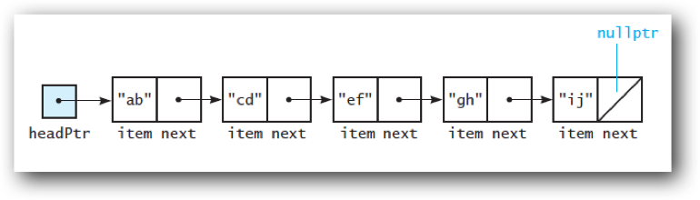

Lecture Activity

Write **pseudocode** for a sequence of steps to add to the **front** of the chain



    Pseudocode (English-like)

• Instantiate a new node and let temp_ptr point to it

• Set temp_ptr->next to point to the same node head_ptr_ points to

• Set head_ptr to point to the same node temp_ptr points to

• Set temp_ptr to nullptr

Pseudocode (Code-like)

temp_ptr = new node

temp_ptr->next = head_ptr_

head_ptr = temp_ptr

temp_ptr = nullptr

LinkedBag Implementation



The add method ADD at beginning of chain is easy because we have head_ptr_

#include “LinkedBag.hpp”

template<typename ItemType>  
bool LinkedBag<ItemType>::add(const ItemType& new_entry)

{

// Add to beginning of chain: new node references rest of chain; // (head_ptr_ is null if chain is empty)   
Node<ItemType>* new_node_ptr = newNode<ItemType>;



Dynamic memory allocation adding notes to heap_

new_node_ptr->setItem(new_entry);

new_node_ptr->setNext(head_ptr_); // New node points to chain

item_count_++;

return true; } // end add



DYNAMIC MEMORY ALLOCATION ADDING NODES TO THE HEAP

head_ptr_ = new_node_ptr;// New node is now first node  Dynamic memory

!23

The add method  
Add at beginning of chain is easy because we have head_ptr_

allocation  
Adding nodes to the heap!

